Task 7: Interactive Web Form with Events & Functions
Aim: To develop an interactive feedback form system using HTML, CSS, JavaScript, Node.js, and MySQL that performs real-time input validation, enhances user interaction (hover + double-click), and securely stores feedback data in a database.
Algorithm :
- Start
- Display feedback form (Name, Email, Message)
- User enters input
- Validate inputs on keypress
- Highlight fields on mouse hover
- On double-click submit:
  - Collect form data
  - Check all fields are valid
- Send data to backend (POST request)
- Server validates input again
- Insert data into MySQL database
- Send response to frontend
- Display success or error message
- End

Program:
Index.html
<!DOCTYPE html>
<html>
<head>
<title>Feedback Form</title>
<link rel="stylesheet" href="style.css">
</head>
<body>
<div class="container">
<h2>Customer Feedback</h2>

<input type="text" id="name" placeholder="Name"
onkeypress="validateName()" onmouseover="highlight(this)">
<input type="email" id="email" placeholder="Email"
onkeypress="validateEmail()" onmouseover="highlight(this)">
<textarea id="message" placeholder="Message"
onkeypress="validateMessage()" onmouseover="highlight(this)"></textarea>
<button ondblclick="submitForm()">Double Click to Submit</button>
<p id="status"></p>
</div>
<script src="script.js"></script>
</body>
</html>
Style.css
body {
font-family: Arial;
background: #f4f4f4;
}
.container {
width: 400px;
margin: 50px auto;
padding: 20px;
background: white;
border-radius: 10px;
}
input, textarea {
width: 100%;
margin: 10px 0;
padding: 10px;
border: 1px solid #ccc;
}

input:hover, textarea:hover {
border-color: blue;
background: #eef6ff;
}
button {
width: 100%;
padding: 10px;
background: green;
color: white;
border: none;
cursor: pointer;
}
Script.js
function validateName() {
let name = document.getElementById("name").value;
if (name.length < 3) {
showStatus("Name must be at least 3 characters", "red");
} else {
showStatus("", "");
}}
function validateEmail() {
let email = document.getElementById("email").value;
let regex = /^[^\s@]+@[^\s@]+\.[^\s@]+$/;
if (!regex.test(email)) {
showStatus("Invalid email format", "red");
} else {
showStatus("", "");
}}
function validateMessage() {
let msg = document.getElementById("message").value;
if (msg.length < 10) {
showStatus("Message too short", "red");
} else {
showStatus("", "");
}}
// hover highlight function
function highlight(el) {
el.style.boxShadow = "0 0 10px blue";}
// status display helper
function showStatus(msg, color) {
let status = document.getElementById("status");
status.innerText = msg;
status.style.color = color;}
// submit on double click
async function submitForm() {
let data = {
name: document.getElementById("name").value,
email: document.getElementById("email").value,
message: document.getElementById("message").value
};
const res = await fetch("http://localhost:3000/feedback", {
method: "POST",
headers: { "Content-Type": "application/json" },
body: JSON.stringify(data)
});

const result = await res.json();
if (result.success) {
showStatus("Feedback submitted successfully!", "green");
} else {
showStatus("Submission failed", "red");
}}
Output:
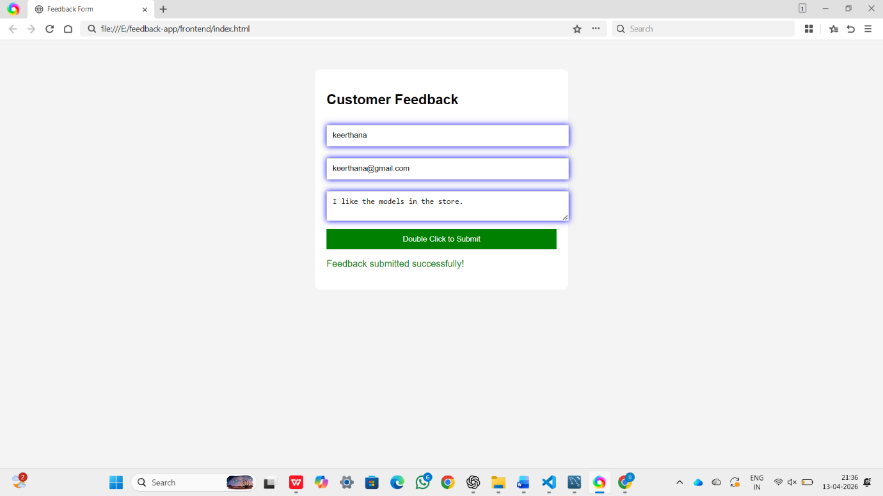

Result:
The interactive feedback form was successfully developed.
User inputs are validated in real-time, fields are highlighted on hover, and feedback is submitted using double-click. The data is stored in the MySQL database, and a confirmation message is displayed after successful submission.

